Humanities 110 Final Examination
Tuesday, May 7, 2024
9am - 12 noon

This exam is scheduled for three hours. Part One requires 45 minutes. Each essay in Part Two and Part Three requires 1 hour.

Make sure to use some of this time for editing and to divide your time evenly within each section.

This is an open-book, open-note exam. While you may consult the assigned course materials, lectures, your notes, and handouts, you may not consult other online materials or other people for the duration of the exam. For this exam, as for all other exams at Reed, the Honor Principle applies. Failure to adhere to the requirements set out above will constitute academic misconduct.

Note: students MAY email their responses to the conference leader unless their conference leader has told them NOT to do so. Students who have accommodations from DAR are encouraged to use them for the exam. If your accommodation includes extra time, you may find it helpful to remind your conference leader of this if you have not done so already.

Part One (approximately 45 minutes; make sure to use some of this time for editing):

Do a close reading of one passage or artwork from each of the two categories. Be sure to identify the key themes in the work and explain why they are important to the work itself and/or to the larger themes in the course this semester.

Category One [pick one of the two options A or B]

Please be sure to consider how the individual image pictured below relates to the larger work of which it is a part.

- Lienzo de Tlaxcala
(Slide 9, https://rdc.reed.edu/workspace/13700/slideshow?p=9&pp=100, 16th century, artists unknown, Tlaxcala, Mexico)
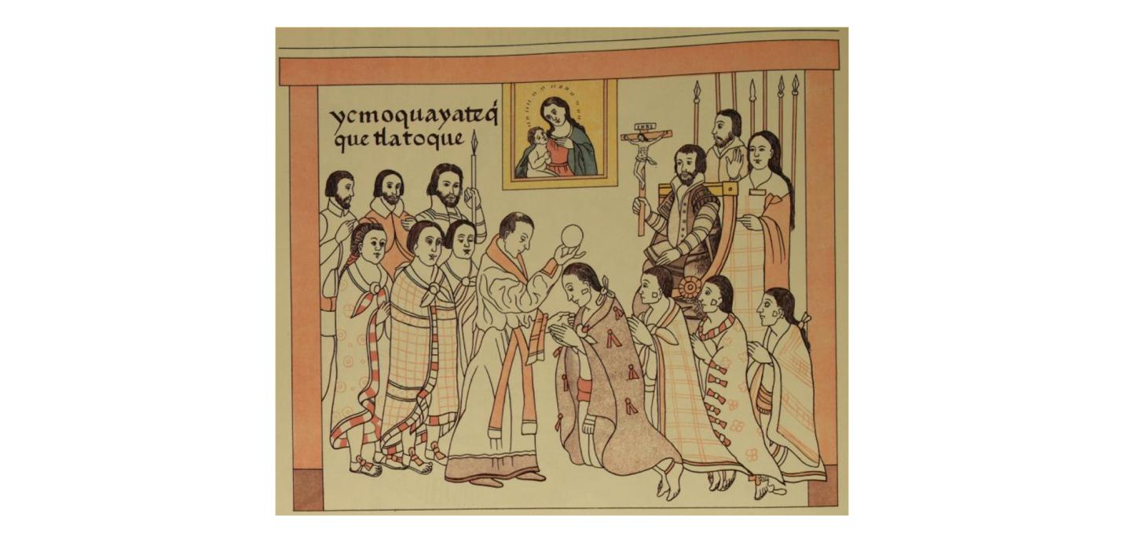
- “The female workers were the last to arrive north.” (Jacob Lawrence, Migration Series, number 57, 1940–41, New York City,
https://lawrencemigration.phillipscollection.org/the-migration-series/panels/57/the-female-workers-were-the-last-to-arrive-north )

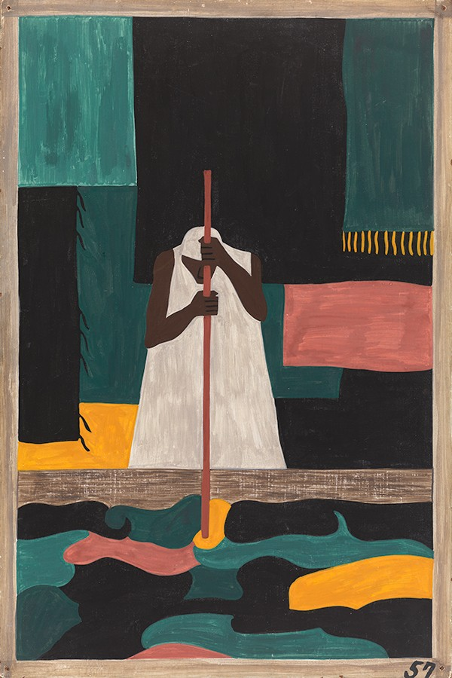

Category Two [pick one of the two options, A or B]

- Countee Cullen, “Yet Do I Marvel” (The Portable Harlem Renaissance Reader, Countee Cullen, 1925, p. 244)

I doubt not God is good, well-meaning, kind,
And did He stoop to quibble could tell why
The little buried mole continues blind,
Why flesh that mirrors Him must some day die,
Make plain the reason tortured Tantalus
Is baited by the fickle fruit, declare
If merely brute caprice dooms Sisyphus
To struggle up a never-ending stair.
Inscrutable His ways are, and immune
To catechism by a mind too strewn
With petty cares to slightly understand
What awful brain compels His awful hand.
Yet do I marvel at this curious thing:
To make a poet black, and bid him sing!

- Sor Juana Inés de la Cruz, Reply to Sor Filotea (Poems, Protest, and a Dream, Sor Juana Inés de la Cruz, 1691, p. 41)

“Once in my presence two young girls were spinning a top and scarcely had I seen the motion and the figure described, when I began out of this madness of mine, to meditate on the effortless motus of the spherical form, and how the impulse persisted even when free and independent of its cause – for the top continued to dance even at some distance from the child’s hand, which was the causal force” (Reply, 41)

Part Two (one essay; approximately one hour; make sure to use some of this time for editing):

Select ONE of the two essay questions that require you to trace a theme in two of the works we have studied this semester, including one from the Mexico section and one from the Harlem section.

- Write an essay that compares and contrasts how the tensions between individual and collective identity are represented in two works that we studied this semester (one from each unit). You might want to consider how the works represent the relationship between one’s individual identity and one’s social class; the search for an individual or community identity in the context of capitalism and modernity; or, the difficulties of social advancement in the context of prejudice.

Pick one work from each unit:

Mexico unit: Pacheco, Battles in the Desert; Luis Buñuel, Los Olvidados; Subcomandante Marcos, “Fourth Declaration of the Lacandon Jungle” (1996); the Casta Paintings; Sor Juana, “Reply to Sor Filotea,”; Poniatowska, Massacre in Mexico

Harlem unit: Hurston, “Sweat”; Hurston, Their Eyes Were Watching God; Nugent, “Smoke, Lilies And Jade”; Hartman, Wayward Lives, Du Bois, Souls of Black Folk; Hughes, “The Negro Artist and the Racial Mountain”; Garvey, “Africa for the Africans”; Universal Negro Improvement Association, “Declaration of the Rights of the Negro Peoples of the World.”

- Analyze the relationship between art and politics in two works that we studied this semester (one from each unit). You might want to consider: how art expresses or frees itself from political agendas; how an artistic medium addresses political conflict or oppression; how art can be a medium for political change.

Pick one work from each unit:

Mexico unit: Rivera’s mural at the National Palace, Siqueiros’ mural in the office headquarters of the Mexican Electricians Union, Buñuel’s Los Olvidados, Pacheco’s Battles in the Desert, Poniatowska, Massacre in Mexico

Harlem unit: Lawrence, The Migration Series; Hurston, Their Eyes Were Watching God; Hurston, “Sweat”; Nugent, “Smoke, Lilies And Jade”; McKay, “The White House” or “If We Must Die”; Du Bois, “Of the Coming of John.”

Part Three (one essay; approximately one hour; make sure to use some of this time for editing):

Choose ONE of the following questions on Invisible Man.

- Take any two objects in Invisible Man and analyze their importance in the novel. You could consider, for example, the coin bank, Sambo doll, Brother Tarp’s link of chain, briefcase, paint, lightbulb, record player, statue of the Founder, the yam, etc. What is the function of these objects? What do they express about identity, personhood, history, or invisibility?

- In the novel’s Epilogue, the narrator states that even an Invisible Man has a socially responsible role to play. What do the Prologue and the Epilogue suggest that role might be? How does that contrast with the previous roles that he played in different social contexts (for example, the Brotherhood, at college, at Liberty Paint Factory)?

